

Peripheral & Interfacing(CSE 315)

Department of CSE

**Assignment No: 02**

|  |  |
| --- | --- |
| **Topic/Question:** | 1.Write a sketch with function to find the average of two numbers.  2.Write a sketch with function to find the average of three numbers with serial output (after decimal- “.” it will print 4 numbers).  3.write about: Seral.write(), Serial.println(), Serial.available(), Serial.read() |

Date of Submission: 20 Jul 2020

|  |  |
| --- | --- |
| Submitted by | Submitted to |
| Name: Niamul Hasan  Id: **17201026**  Semester: 3-2  Section: A | [Abdullah Al Omar](http://www.uap-bd.edu/cse/faculty_info/omar.html)  Lecturer  UAP |

1. Write a sketch with function to find the average of two numbers:

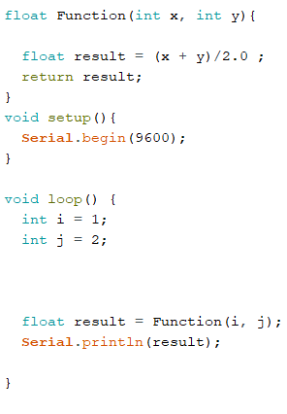

2.Write a sketch with function to find the average of three numbers with serial output (after decimal- “.” it will print 4 numbers):

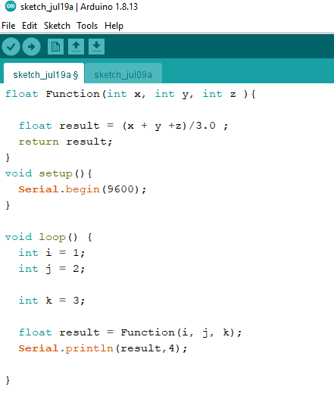

3.write about: Seral.write(), Serial.println(), Serial.available(), Serial.read():

|  |  |  |  |  |  |  |  |
| --- | --- | --- | --- | --- | --- | --- | --- |
| * **Serial.write():**   **Description:**  Writes binary data to the serial port. This data is sent as a byte or series of bytes; to send the characters representing the digits of a number use the [print()](https://www.arduino.cc/reference/en/language/functions/communication/serial/print) function instead.      **Syntax:**  Serial.write(val)  Serial.write(str)  Serial.write(buf, len)   |  |  | | --- | --- | | **CODE:** | **Output:** | | **Serial.write(72);**  **Serial.write(69);**  **Serial.write(76);**  **Serial.write(79);** | **H**  **E**  **L**  **O** |  **Parameters:** Serial: serial port object. See the list of available serial ports for each board on the [Serial main page](https://www.arduino.cc/reference/en/language/functions/communication/serial).  val: a value to send as a single byte.  str: a string to send as a series of bytes.  buf: an array to send as a series of bytes.  len: the number of bytes to be sent from the array. **Returns:** write() will return the number of bytes written, though reading that number is optional. Data type: size_t. Example use of Serial.write():    * **Serial.println():**   **Description:**  Writes binary data to the serial port. This data is sent as a byte or series of bytes; to send the characters representing the digits of a number use the [print()](https://www.arduino.cc/reference/en/language/functions/communication/serial/print) function instead.    **Syntax:**  Serial.println(val)  Serial.println(val, format) **Parameters:**  |  | | --- | | Serial: serial port object. See the list of available serial ports for each board on the [Serial main page](https://www.arduino.cc/reference/en/language/functions/communication/serial).  val: the value to print. Allowed data types: any data type.  format: specifies the number base (for integral data types) or number of decimal places (for floating point types). |  **Returns:** println() returns the number of bytes written, though reading that number is optional. Data type: size_t. **Example use of Serial.println():**  * **Serial.available():**   **Description:**  Get the number of bytes (characters) available for reading from the serial port. This is data that’s already arrived and stored in the serial receive buffer (which holds 64 bytes).  Serial.available() inherits from the [Stream](https://www.arduino.cc/reference/en/language/functions/communication/stream) utility class    **Syntax:**  Serial.available()   **Parameters:**  |  | | --- | | Serial: serial port object. See the list of available serial ports for each board on the [Serial main page](https://www.arduino.cc/reference/en/language/functions/communication/serial). |  **Returns:** The number of bytes available to read. **Example use of Serial.available():**  * **Serial.read():**   **Description:**  Reads incoming serial data.  Serial.read() inherits from the [Stream](https://www.arduino.cc/reference/en/language/functions/communication/stream) utility class.    **Syntax:**  Serial.read()   **Parameters:**  |  | | --- | | Serial: serial port object. See the list of available serial ports for each board on the [Serial main page](https://www.arduino.cc/reference/en/language/functions/communication/serial). |  **Returns:** The first byte of incoming serial data available (or -1 if no data is available). Data type: int **Example use of Serial.read():** |
|  |
|  |